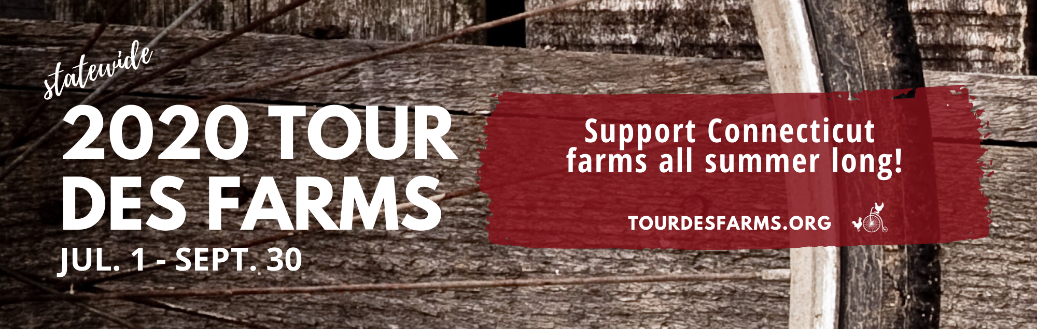

Welcome to the 2020 Connecticut Tour des Farms!
As we prepare for the Connecticut Tour des Farms summer long event, we want to provide you a digital TdF bib for use on the rides.
Customize your digital bib prior to printing:
- Add your name/nickname/affiliation
- Add hashtags, logos, graphics or inspirational words to express your personality

Wear & share your bib:
Once you have customized your digital bib, simply print it out. Wear and share your bib with others through photos and social media while taking part in this year’s Tour des Farms.
We want to see your bibs! Don’t forget to use the hashtags #BikeCTFarms #2020TDF on social media and tag us @ctrcd.

Customizable bib:
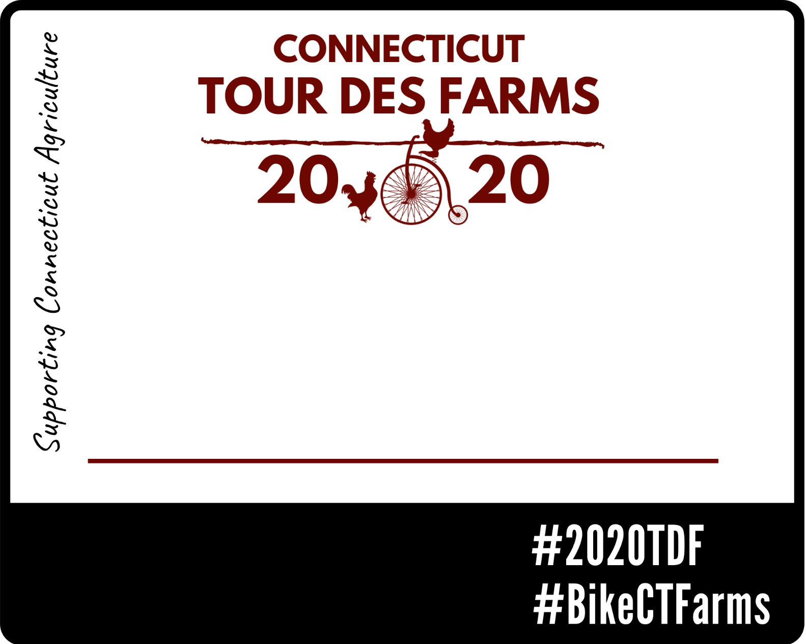
Click or tap here to enter text.

